BCS Certificates In Enterprise and Solution Architecture

ACKO Case Study - Workshops
In these workshop sessions you work from the LCMS case study and the BCS syllabus and reference model to identify information views that are potential questions from the case study. We cannot look at every element in the workshops (that would require a much longer course) nor do we know what the actual questions are. The workshops will give you a good coverage of likely questions. If you wish to investigate the ACKO case study further, then you will need to do so the evenings after the course sessions have finished.

Exercise 1 – Enterprise Precursors – Architecture Context
Topics | ACKO Content on This Topic | Information Located in Case Study Sections
Vision | - Successful trading company in the north with a reputation based on priced and quality | 1.2.1  1.2.2
Mission | - Retailing furniture, white goods, electrical and household appliances. | 1.2.3
Mission Statement
Stakeholders | - Competitors, suppliers, customers, partner firms, International Consultant’s Company (ICC), Fulfilment Agencies, ACKO management, ACKO employees (stores, warehouses, head office) etc., Project Manager, Applications Manager, Data Manager, Systems Manager, Operations Manager | Lots of sections especially  2.3
Actors / Roles
Locations | - Retail Stores (100 +), Head Office, Depots/Warehouses (5)  - New ACKO from Home Call Centre, ACKO from Home Warehouse, ACKO from Home Central Systems | 3.3  3.4
Drivers | - Rapidly changing market (external)  - Poor record on strategic projects (internal)  - World is changing rapidly (external)  - Household goods market is very competitive (competitive)  - Major competitors striving to be number 1 (competitive)  - Public’s concern over security of financial transactions (external)  - Competitor’s using new tech opening up new channels (external) | 1.2  1.3  2.2
Principles | - Work within sensible limits of availability and performance  - Set realistic expectations with our users  - Reuse (ACKO plan to use their own existing IT Services where possible).  - Ease of system interoperability and integration over time (ACKO from home must fit smoothly within existing systems and future IT investments) | 3.5  2.3  2.6
Policies | - ACKO from home must fit smoothly within existing systems and future IT investments.  - Where existing systems deliver the services we need (…..) then we must use them. | 2.6

Exercise 2 – Business Architecture – Solution Context
Topics | ACKO Content on This Topic | Information Located in Case Study Sections
Business Rules

Strategy / Plan(s) | - Win new customers through new sales channels.  - Introduce an ACKO Account (with credit card?) in the future. | 1.3  2.5
Programme | - Build ACKO from home – home shopping system  - Open flagship stores overseas. | 1.1  1.2
Project | - Definition and build of the Order Management System – including infrastructure.  - Later implementation of in-store Kiosks.  - Later implementation of new warehouses and the call centre. | 1.1  2.2  2.6
Goals | - Reach new customers abroad and where no stores.  - Offer a wider range of goods than in-store.  - Deliver a distinctive ACKO experience.  - Build stronger relationships with customers.  - Reduce costs by moving to internet from telesales.  - Avoid disruption and extra workload on store personnel. | 1.3  2.1  2.4
Objectives | - Get solution in-place within 3 months – ready for New Year sales. | 2.2  2.6
Business Requirements | - Customers get catalogue from stores or post. (Business)  - Place orders by telephone from the catalogue. (Business)  - Browse catalogue on-line and place orders. (Business)  - Provide in-store kiosks to make internet orders. (Business)  - Security services must be implemented. (Business)  - Key word and product search. (Business)  - Ability to request home machine installation. (Business)  - Home machine maintenance. (Business)  - Local order printing or print copy sent by mail. (Business)  - Tailor special offers by channels. (Business)  - Customers can review their order histories. (Business)  - Handle order status change (Business – Process)  - OMS system will provide information to fulfilment agencies (Business – Process / Data)  - Handle order status changes as they are fulfilled (Business – Process / Data)  - Will need to provide necessary sales information to the right systems and product and price changes into the catalogue from elsewhere in ACKO (Business – Process / Data)  - Make sure the different systems can align the necessary information as orders are processed through warehouses and delivered (Business – Process / Data)  - Where an order is fulfilled by more than one agency several credit/debit card transactions may be required. (Business) | 2.2  2.3  2.5  2.6  3.5
Constraints  (Limit solution options) | - ACKO plan to use their own existing IT Services where possible (Services/Technology).  - ACKO have decided that fulfilment aspects will be based on a series of new shopping warehouses, not their existing stores. (Business)  - Warehouses will either resemble an ACKO store … or be a variation of ACKO’s existing Warehouses … (Business)  - Customers will pay for their …. Goods via a Debit or Credit card. (Business)  - Customers will use the bank connection via ACKO’s Head Office to authorise transactions / settlement will be processed by ACKO’s existing Banking arrangements. Technology / Process)  - ACKO are running on a tight budget. (Business)  - Anxious to launch by the New Year. (Business)  - The OMS will be implemented separately from ACKO’s existing IT. (Services / Technology)  - The new system will have its own Customer Management System. (Service / Technology)  - Potential need to extend the new CIS to become a corporate system. (Service / Technology / Data)  - Understand (and address) extra load on existing system caused by the new system. (Technology NF)  - The new OMS will communicate with existing systems using the planned ACXKO web and collaboration tools (Technology)  - Use existing databases wherever we can (Data / Technology)  - Later implementation of in-store Kiosks. (Business)  - Later implementation of new warehouses and the call centre. (Business)  - Decided Java should not run on the clients (Technology). | 2.3  2.4  2.5  2.6
Assumptions | - Existing systems can provide data and be synchronised with the new systems.  - Separating the existing and new systems will reduce risk to disruption of current services. | 3.2  2.4
Standards & Regulations | - Use IBM mainframe technologies (defacto)  - Use of SAP (defacto)  - Lotus Notes (defacto) | 3.1
Security Concerns | - Must address public concerns about the security of financial transactions. | 2.2
New Capabilities Required | - Take and manage orders from multiple channels  - Fulfil orders taken via the new channels | General
Key Information / Data Entities | - Customer  - Product / Service  - Order  - Location  - Payment  - Supplier  - Party  - Catalogue | Many places
Key Application / Software Entities | - Ordering system on client devices  - Customer account management  - Payment | 2.2  2.5
Key Technology / Infrastructure Entities | - Internet technologies  - Integration technologies | 2.1  2.3  3.3
Baseline Business Services | - Point of sale  - Stock management  - Payments including Card payment  - Catalogue creation  - Catalogue delivery  - Telephone ordering  - Product management  - Product delivery  - Installation  - Servicing  - Telephone enquiry service | 1.3  2.2  2.3
Target Business Services | - Sign up to ACKO account  - Manage ACKO account  - Browse and order on line  - Browse and order by kiosk  - Card payment | 1.3  2.2  2.4
Target Business Processes (Activities) | - Sign up for account  - Log on to service  - Search catalogue on-line  - Order goods on-line  - Cancel order on-line  - Make payment for order on-line  - Change order on-line  - Request installation on-line  - Buy service agreement on-line  - Print orders on-line  - Request print of order on-line  - Make special offer  - View order history on-line | 2.2
Outline Context Diagram | 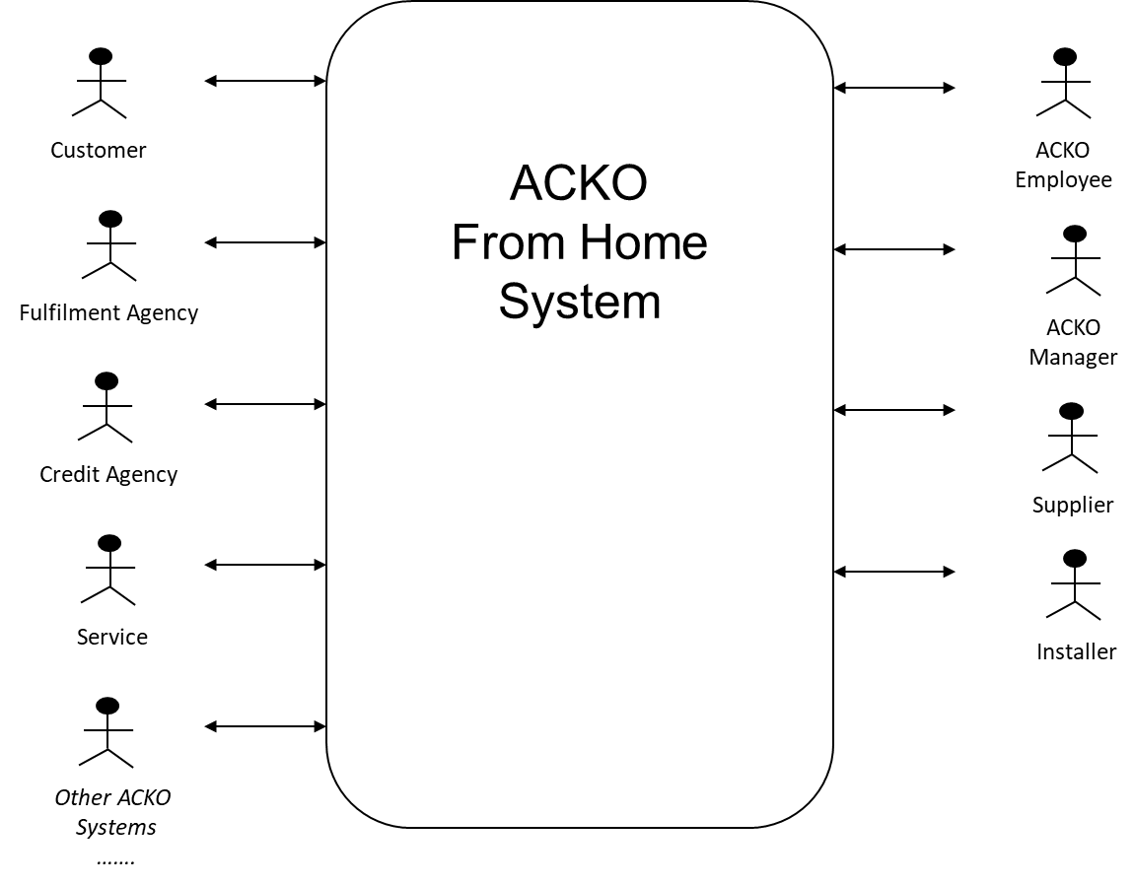

Exercise 3 – Application, SW-Component and Data Architecture
Topics | ACKO Content on This Topic | Information Located in Case Study Sections
Baseline Applications | - Customer  - Finance  - Payroll  - Product Management  - Product Management System (CICS/Cobol)  - Central Supply Chain  - Stores Sales System (SAP)  - Groupware System (Lotus Notes)  - Time and Attendance  - Marketing (Data Warehouse)  - Point of Sale  - Goods Handling (inc Hand Held terminals)  - Personal Productivity (MS Office and Lotus Based)  - Environment management and file and print services  - Credit Agency Card Payment Authorisation (External) | 2.5  3.1  3.3
Target Applications | - ACKO from Home System  - Ordering from anywhere (on-line / kiosk)  - Manage account (on-line)  - Track order and order history (on-line)  - ACKO from Home Call Centre  - ACKO from Home Warehousing  - ACKO from Home Central | 2.2  3.4
Component Interoperation Styles | - REST for internet/www aspects  - Note where data is manged centrally SOA or DO may be an appropriate style. | General style
Data Entities | - Party / Customer / Supplier / Partner / Employee  - Customer Account  - Product / Service  - Order  - Location  - Payment  - Catalogue | Many Places
Baseline Data Stores | - Product Catalogue (SAP S390 – Head Office))  - Stock and Supplier Details (S390 – Head Office)  - Supplier, Delivery, Store Stock (RS6000 – Depot)  - Offers, Brand Details (RS6000 – Head Office)  - Customer Data Warehouse, Customer Data (UNIX – Head Office)  - Time & Attendance (RS6000 – Stores)  - Credit Card Hot List (Rs6000 – Stores) | 3.2
Target Data Stores | - Extended customer order history  - Customer accounts | 3.2  2.5
Data Stores Where Client-Side Caching Might help | - Home Page  - Catalogue
Business & Application Services View | 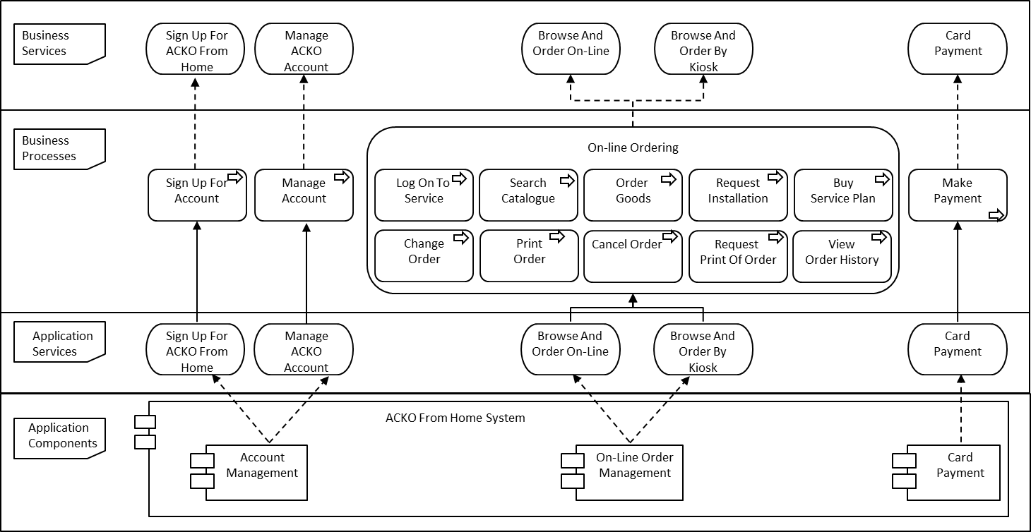
Business, Application Services & Data Objects View | 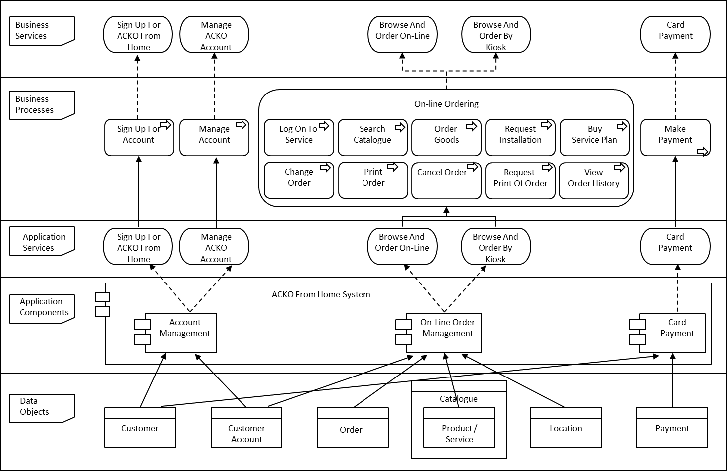

Exercise 4 – Infrastructure
Topics | ACKO Content on This Topic | Information Located in Case Study Sections
Baseline Technologies | - IBM Mainframes OS390  - UNIX Servers AIX  - AS 400 OS/400  - EPOS IBM OS/4690, IBM 46802 Tills  - Hand held terminals  - Windows XP  - IE6 / MF Terminal Emulators (3270)  - CICS, IMS, COS/Batch, MQ, Lotus Domino, TCP/IP, Store Loop  - Microsoft Office, Lotus Notes  - Databases in DB2, Oracle, DL1, Ascii Files  - Ascii Files  - C. C++, Cobol, Java, RPG, Basic  - Netwview DM/FTP, Endevor, QDSNX/Netview FTP  - Tivoli, Netview PM, SM/600. Perfmon, SYSBack, OS/400PrfMon, Op’n Navigator, CISCO Works  - TCP/IP over ISDN | 3.1  3.3
Target Technologies | - Extended internet access, bandwidth and services  - All major internet browsers | 3.1
Network Topology | - WAN for ACKO organisation applications (Stores, Depots, Head Office)  - Point to Point Credit Agency  - Supplier Gateways | 3.1
Technology Requirements | - The system needs to support all major current browsers. (Technology)  - They need robust, flexible systems than will last for years (NF)  - Warehouse system operates 24 hours a day 6 days a week (NF)  - Home shopping (ordering service) 24 hours a day almost 365 days a year (NF)  - Support 30,000 customers per year, 200 simultaneous catalogue access, 60-70 orders per day, 7,000 visitors per day (NF) | 3.1  3.4  3.5
Business, Application & Infrastructure Services View | 