**Software Services Inc.**

**Our company:**

Is a leading group of software development companies providing a full range of consulting, development and operational services around the globe. Has a combination of specialist people working for specialist companies with the ability to work together and connect those skills and services together to deliver truly world class integrated end to end services to our clients.

Covers a wide portfolio of services including:

* Software development and maintenance
* Analytics and business intelligence
* Data centre and network operations
* Service management and problem and disaster recovery
* Data management and data insight
* Security and network management and protection
* Skill and knowledge development
* Business and technical innovation and insight

**Our overarching goal:**

To increasingly bring our capabilities together **more** seamlessly to provide a best in class service across multiple geographies to many different types of client while retaining the in-depth knowledge and focus of each of our specialist companies all the while growing our client base, operating revenues and profitability.

**Our response:**

We will increasingly:

* Provide highly efficient centralised services for standardised business operations including, planning, finance, legal, HR, IT, physical asset management; every administrative hour saved is an extra hour to be devoted to the pursuit of professional excellence.
* Encourage each specialist company to naturally work together, share knowledge and look for both internal and cross company synergies in specialist operations.
* Support each specialist company to maintain and/or develop market leadership in their own distinctive area.
* Develop and acquire new specialist companies to further our portfolio of world leading software service for our clients.

# Our focus:

* Developing and acquiring companies
* Developing and acquiring talent, skills and knowledge
* Integration between our specialist companies
* Focus on proving our clients with true end to end services that they can be assured are delivered with full accountability for performance by Software Service Inc.

**Our current geographical spread**

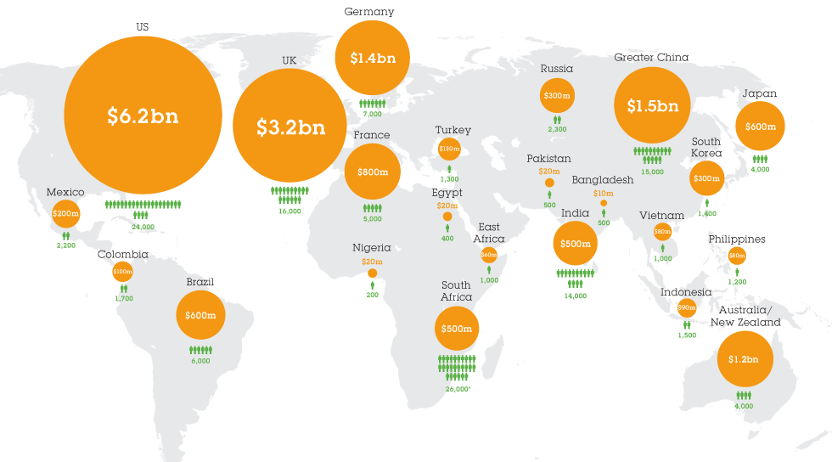

# You will have 10 - 15 minutes to provide an answer to each of the questions, based on the materials presented in the relevant course section, the BCS syllabus and your personal experience. There is no one right answer, but relevant content from the course should be referenced. Depending on how the course is being delivered and progressing you should type in your answer to the chat when requested and / or prepared to present your answers in a 2-3 minute verbal presentation.

# Exercise 1 – Fundamentals of Architecture

Which architecture domains are the most important in evolving the architecture landscape of Software Services and which viewpoints and views would be most relevant?

# Exercise 2 – Business Architecture

What is the main motivation behind the need to change and which business capabilities may need to be improved?

**Exercise 3 – Applications Architecture**

# Which applications and interoperability concerns would be most impacted and how would you approach them?

# Exercise 4 – Data Architecture

Which data items would be most impacted and how would you deal with the technical, social, regulatory and legal issues likely to be encountered?

# Exercise 5 – Infrastructure Architecture

Describe what you should consider in the development of cloud based infrastructure solutions from security, performance, regulatory and business continuity perspectives.

# Exercise 6 – Software Architecture

How would software design best contribute to an integrated, evolvable and interoperable architecture?

# Exercise 7 – Security Architecture

What are the most important security aspects to be considered, how would you test security and would zero trust be an appropriate consideration?

# Exercise 8 – Solution Architecture

# Which would be the most relevant architecture standard as a reference model for this organisation and what would be the most important aspects that you need to address to deliver a well-formed overall architecture landscape?