# Software Services Inc.

**Our company:**

Is a leading group of software development companies providing a full range of consulting, development and operational services around the globe.

Has a combination of specialist people working for specialist companies with the ability to work together and connect those skills and services together to deliver truly world class integrated end to end services to our clients.

Covers a wide portfolio of services including:

* Software development and maintenance
* Analytics and business intelligence
* Data centre and network operations
* Service management and problem and disaster recovery
* Data management and data insight
* Security and network management and protection
* Skill and knowledge development
* Business and technical innovation and insight

**Our overarching goal:**

To increasingly bring our capabilities together **more** seamlessly to provide a best in class service across multiple geographies to many different types of client while retaining the in-depth knowledge and focus of each of our specialist companies all the while growing our client base, operating revenues and profitability.

**Our response:**

We will increasingly:

* Provide highly efficient centralised services for standardised business operations including, planning, finance, legal, HR, IT, physical asset management; every administrative hour saved is an extra hour to be devoted to the pursuit of professional excellence.
* Encourage each specialist company to naturally work together, share knowledge and look for both internal and cross company synergies in specialist operations.
* Support each specialist company to maintain and/or develop market leadership in their own distinctive area.
* Develop and acquire new specialist companies to further our portfolio of world leading software service for our clients.

# Our focus:

* Developing and acquiring companies
* Developing and acquiring talent, skills and knowledge
* Integration between our specialist companies
* Focus on proving our clients with true end to end services that they can be assured are delivered with full accountability for performance by Software Service Inc.

**Our planned development in new markets**

[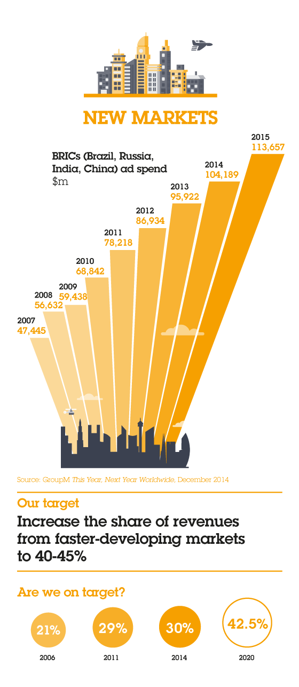](http://www.wpp.com/annualreports/2014/~/media/microsites/annual-reports/2014/infographics/newmarkets.png)

**Our current geographical spread**

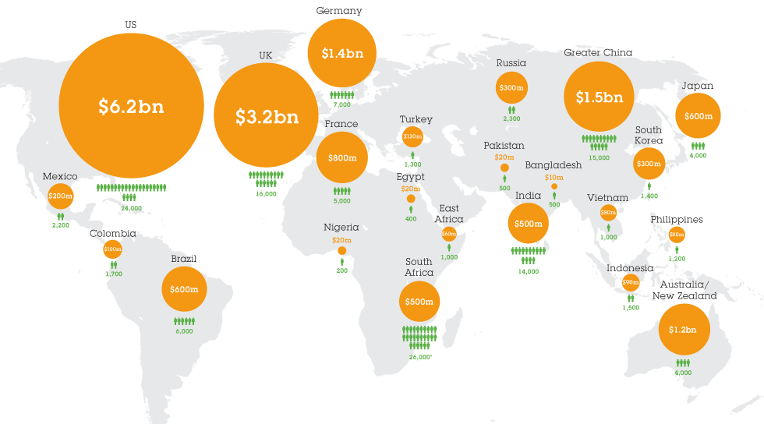

# Exercise 1

From the case study description flesh out what you believe might be the drivers that led to the overarching goal and what the specific objectives (with KPIs) might be.

# Exercise 2

Identify up to 3 key architecture principles complete a principles template for one of those principles.

**Exercise 3**

# From the case study description identify 3 potential stakeholders and complete an entry in a stakeholder matrix for of them.

# Exercise 4

From the case study description identify @ 5 business capabilities that might be important for Software Services Inc.

# Exercise 5

Describe a potential target Architecture Vision and the proposed transition architectures towards that vision.

*(Note: An architecture vision is a clear “sketch” of how the future will be describing key architectural elements presented in any of a number of different formats/media)*

# Exercise 6

Identify 2 main processes that may be key to the first transition step towards the target architecture and include measures of success and process outcomes.

# Exercise 7

Define a first draft of a possible logical information model and identify possible key issues with the current quality of this data.

# Exercise 8

Identify potential applications for 1 - 2 of the business capabilities identified in exercise 3 that are key to the first transition step towards the target architecture and propose their technical architecture.

# Exercise 9

Propose a technology architecture pattern for the organisation.

# Exercise 10

Propose the first 2-3 projects that may be required during the initial transition phase, identify their key deliverables and risk levels.

# *Note that this course does not teach specific modelling techniques or notations in detail, therefore many of the sample answers use the catalogue / matrix style deliverables from TOGAF. However, if you wish to use a relevant model/diagram in an exercise please do.*

The following are sample answers. You may have identified different answers to each question. Use the example answers to consider how well you have been able to capture and present the information you wanted to.

# Exercise 1

From the case study description flesh out what you believe might be the drivers that led to the overarching goal and what the specific objectives (with KPIs) might be.

|  |
| --- |
| Drivers |
| Globalisation with faster growth in new/emerging markets |
| Continued market cost pressure requiring economies of scale through shared services between specialist companies in the group |
| Increasing demand from large clients for “one-company” service |
| Difficulty in integrating information and skills across the group to deliver a “one-company” service. |
| Need for capability in new geographies (potentially by acquisition) |

|  |
| --- |
| Overarching Goal |
| To increasingly bring our capabilities together **more** seamlessly to provide a best in class service across multiple geographies to many different types of client while retaining the in-depth knowledge and focus of each of our specialist companies all the while growing our client base, operating revenues and profitability. |

|  |  |
| --- | --- |
| Objectives | KPIs |
| Set up and implement shared services across the group | For first transition (covering 5 internal companies) to be running effectively by the end of 2015 |
|  | For the final transition (for all internal companies to be running effectively) by the end of 2016. |
| Implement one-company proposal capability for major clients | For first transition (with 5 test clients) to be in use by the end of 2015 |
|  | For the final transition (for all internal companies to be running effectively) by the end of 2016. |
| To lower the cost of delivery of shared service business capabilities, while maintaining quality and increasing profitability. | Shared service cost (profiled against company growth) to be 10% lower at the end of 2016 compared to the end of 2014. |
|  | Shared service cost quality index to be as good if not better at the end of 2016 compared to the end of 2014. |
|  | Overall operational profitability of the group to be 10% higher at the end of 2016 compared to the end of 2014. |

# Exercise 2

Identify up to 10 key architecture principles for and complete a principles template for one of those principles.

**Principles List**

|  |  |  |
| --- | --- | --- |
| **No** | **Name** | **Domain** |
| 01 | Reuse, before buy before build. | Enterprise |
| 02 | Minimise the number of similar products and applications. | Enterprise, Application |
| 03 | Adopt components and integration based on standards. | Enterprise |
| 04 | Implement modular architectures that will evolve across generations of technology change. | Enterprise |
| 05 | Design solutions for optimal Total Cost of Ownership and on-going serviceability. | Enterprise, Operational |
| 06 | Design and test solutions for end to end business service levels. | Enterprise |
| 07 | All solution components should satisfy legal and regulatory standards. | Enterprise |
| 08 | Information and data and access to information systems should be formally managed and controlled taking account of global and local issues. | Enterprise, Data |
| 09 | Information and data should be secured (in storage, use and transit) and safely backed up as necessary taking account of global and local issues. | Enterprise, Data |
| 10 | Solutions should be designed to deliver the right balance of general and localised use and utilisation worldwide as necessary. | Enterprise |
| 11 | All solutions should be formally governed in line with the defined enterprise and domain architectures. | Enterprise |
| 12 | Solutions development should follow the appropriate lifecycle; market test / agile - incremental delivery / fully engineered. | Enterprise |

**01 - Reuse, before buy before build**

|  |  |
| --- | --- |
| **Statement:** | We should reuse components that can be reused effectively; before looking for generic industry standard components we can buy at reasonable cost; before creating organisation specific components only used by us. |
| **Rationale:** | Reuse (given components can be reused effectively) provides faster implementation and lower cost; generic solutions enable reuse of proven ideas (and often implementations) while organisation specific components built for our specific needs only will likely require significant conceptual and physical development time and cost |
| **Implications:** | We review our existing components before deciding on new ones, we build relationships with suppliers to optimise the potential for sharing and common solutions and only build our own specialist solutions when the components required are either specific to us or ones in areas that we are looking to be thought and or technology leaders. We still need experts and specialists across many areas to ensure that we are making good decisions and that our solutions deliver the required outcomes, performance and quality. |

**02 - Minimise the number of similar products and applications**

|  |  |
| --- | --- |
| **Statement:** | We should remove duplication in technologies and application implementations except in situations where we have deliberately looked to multi source and build in redundancy. |
| **Rationale:** | In the past, we have ended up with multiple solutions and applications for similar services as a result of poor management and control. We need to rationalise what we have and clearly understand on a case by case basis when we need to build in redundancy, not just allow different parts of the organisation to implement overlapping and similar services and systems where a more efficient approach can be implemented. |
| **Implications:** | When we multi source and build in redundancy we must clearly document why we have taken that decision. Note that there may be situations and specific solutions for which we will want to do this particularly where we are specifically managing the risk, integrity and security of our business assets. |

**03 - Adopt components and integration based on standards**

|  |  |
| --- | --- |
| **Statement:** |  |
| **Rationale:** |  |
| **Implications:** |  |

**04 - Implement modular architectures that will evolve across generations of technology change**

|  |  |
| --- | --- |
| **Statement:** |  |
| **Rationale:** |  |
| **Implications:** |  |

**05 - Design solutions for optimal Total Cost of Ownership and on-going serviceability**

|  |  |
| --- | --- |
| **Statement:** |  |
| **Rationale:** |  |
| **Implications:** |  |

**06 - Design and test solutions for end to end business service levels**

|  |  |
| --- | --- |
| **Statement:** |  |
| **Rationale:** |  |
| **Implications:** |  |

**7 - All solution components should satisfy legal and regulatory standards**

|  |  |
| --- | --- |
| **Statement:** |  |
| **Rationale:** |  |
| **Implications:** |  |

**08 - Information and data and access to information systems should be formally managed and controlled**

|  |  |
| --- | --- |
| **Statement:** |  |
| **Rationale:** |  |
| **Implications:** |  |

**09 - Information and data should be secured (in storage, use and transit) and safely backed up as necessary**

|  |  |
| --- | --- |
| **Statement:** |  |
| **Rationale:** |  |
| **Implications:** |  |

**10 - Solutions should be designed to deliver the right balance of general and localised use as necessary**

|  |  |
| --- | --- |
| **Statement:** |  |
| **Rationale:** |  |
| **Implications:** |  |

**11 - All solutions should be formally governed in line with the defined enterprise and domain architectures**

|  |  |
| --- | --- |
| **Statement:** |  |
| **Rationale:** |  |
| **Implications:** |  |

**12 - Solutions development should follow the appropriate lifecycle;   
market test / agile - incremental delivery / fully engineered**

|  |  |
| --- | --- |
| **Statement:** |  |
| **Rationale:** |  |
| **Implications:** |  |

# Exercise 3

# From the case study 3 potential stakeholders and complete an entry in the stakeholder matrix for of them.

# Potential Stakeholder List

# CXOs / Process managers / Unit managers / Data centre manager / Network manager / Chief architect / Customers/clients / Prospects / Developers / Operational support staff / Accountants / Lawyers / HR / etc.

# Stakeholder Matrix

|  |  |  |  |
| --- | --- | --- | --- |
| Stakeholder | Concerns | Class | Artefacts |
| CEO  (Internal) | Cost, base, market growth, profitability, capability growth, shared services progress. | Keep Satisfied | Business footprint diagramCountry / delivery capability matrixShared services roadmap |
| Data Centre Manager  (Internal) | Operational performance, service capacity, service availability and continuity across geographies | Key player | Technology portfolio catalogueData centre technology roadmapData centre services /processes / matrixData centre footprint diagram |
| Operational Services Clients  (External) | End to end service performance, access to services in relevant geographies. | Keep satisfied | Service catalogue (including service levels)Service / location matrix |

# Exercise 4

From the case study description identify @5 business capabilities that might be important for Software Services Inc.

|  |  |
| --- | --- |
| No | Business Capability |
| 1 | Provide consolidated quotes from all specialist companies for our clients. |
| 2 | Attract, keep and develop leading edge talent. |
| 3 | Provide up to date analytic and business intelligence services (tracking the latest technologies) |
| 4 | Deliver development and operational services in all major geographies. |
| 5 | Implement technical infrastructure and software services quickly and accurately (consistently faster than the competition). |
| 6 | Integrate new acquisitions quickly and efficiently into our developing business infrastructure. |

# Exercise 5

Describe a potential target Architecture Vision and the proposed transition architectures towards that vision.

(Note: An architecture vision is a clear “sketch” of how the future will be describing key architectural elements presented in any of a number of different formats/media)

Narrative:

|  |
| --- |
| “Our people collaborate immediately within and across our specialist companies taking advantage of the latest technology and tools to develop new client solutions faster.” |

Video:

|  |
| --- |
| This could be animated by a video showing people working together, the tools and techniques they use and how in practice they utilize those to create specific new solution building blocks, end to services for clients and/ or operational capabilities. |

Diagram:

|  |
| --- |
|  |

Transition Roadmap:

|  |
| --- |
| Dynamic |

# Exercise 6

Identify 2 main processes that may be key to the first transition step towards the target architecture and include measures of success and process outcomes.

**Key Processes**

|  |  |  |  |
| --- | --- | --- | --- |
| Process | Description | Outcome | Success Measure |
| Create consolidated quote | All specialist companies work together to develop a shared quote ensuring that the different financial and product profiles of the companies are properly addressed and that the single price addresses worldwide implementation and operation of the service as required by the client. | Agreed pricing from all involved specialist companies that creates one overall price can be offered to the client. | A consolidated quote can be created in no more than the current cycle time average (e.g. for major services <= 5 days) preserving or improving current equivalent profitability outcomes. |
| Develop compelling client proposal | The client development team works together to apply the WPP magic to a client addressing their needs at all required locations. | A well-crafted proposal for the service requested by the client. | A complex proposal can be created in less than the current cycle time average (e.g. for major services <= 5 days) preserving or improving current equivalent profitability outcomes. |

# Exercise 7

Define a first draft of a possible logical data model and identify possible key issue with the current quality of this data.

**Important Data Elements**

|  |  |  |  |
| --- | --- | --- | --- |
| Core Type Name | Description | Key Issues | Current Quality |
| Party | A person, organisation or other defined grouping for which the organisation with whom the enterprise wishes to have relationships. | Effective subtyping and role instantiation to capture the exact nature of the relationship with different parties. | Poor - a mix of different entities which reflect roles (employees, customers, suppliers etc.) and poor quality in the data in most existing party type entities. |
| Place | The geographical place where a “party” or “thing” is located. | Identifying the specific unique location and dealing with location projections vertically. | Poor - in particular, the address database of our clients is poor and knowledge of real time locations of employees is not yet in place. |
| Product | Goods and services offered (in the past, present and/or future) by the enterprise. | Sharing properties between products, pricing combined products and structuring product assemblies. | Poor - for combined offerings to our clients, poor product aggregation and integration information and poor pricing information. |

# Logical Data Model

# Exercise 8

Identify potential applications for some of the business capabilities identified in exercise 3 that are key to the first transition step towards the target architecture.

|  |  |  |
| --- | --- | --- |
| Application Name | Description | Business Capabilities Addressed |
| Application deployment | Application to deploy software across the globe within the defined technical architecture. Expect that this will be available off the shelf as part of the partnership with our IT services supplier. | Deliver development and operational services in all major geographies.Implement technical infrastructure and software services quickly and accurately (consistently faster than the competition). |
| Dynamic pricing | A pricing application to capture prices from each company system, consolidate them and apply relevant variations to deal with global delivery. Expect that this will need to be developed specifically for our organisation. | Provide consolidated quotes from all specialist companies for our clients. |
| Analytics engine | An analytics engine environment that works with our existing databases and provides a fast track solution identifying business and market trends. Likely to be provided as a combined product and consultancy services from Big Analytics. | Provide up to date analytic and business intelligence services (tracking the latest technologies) |

# Exercise 9

Propose a technology architecture pattern for the organisation.

**Standard Location and Network Interaction Pattern**



**Standard Data Centre Logical Domain Pattern**



**Standard Application Component Interaction Pattern**



# Exercise 10

Propose the first 2-3 projects that may be required during the initial transition phase, identify their key deliverables and risk levels.

|  |  |  |  |
| --- | --- | --- | --- |
| Project Name | Description | Key Deliverables | Risk Level |
| Pricing | Create the process and systems to generate consolidated prices across our global specialist companies that presents an integrated view for our customers. | Consolidated pricing engine. | HighGetting this wrong may threaten profitability in different geographies. |
| Contracts | Create the process and systems to generate contracts across multiple geographies and legal and regulatory systems. | Standard contract formats for multiple geographies and legal and regulatory system. | Extremely HighThe potential for different combinations of location relating to a single service creates potential for complex commercial, legal and regulatory interactions. |
| Application Deployment | Acquire and implement the capability deploy applications consistently across the globe. | Deployment and assurance application or service for application deployment. (Probably provided by a 3rd party supplier). | MediumThis is a relatively well understood problem but requires consistent deployment across different cultures. |