Software Services Inc.

Our company:
Is a leading group of software development companies providing a full range of consulting, development and operational services around the globe.
Has a combination of specialist people working for specialist companies with the ability to work together and connect those skills and services together to deliver truly world class integrated end to end services to our clients.
Covers a wide portfolio of services including:
- Software development and maintenance
- Analytics and business intelligence
- Data centre and network operations
- Service management and problem and disaster recovery
- Data management and data insight
- Security and network management and protection
- Skill and knowledge development
- Business and technical innovation and insight
Our overarching goal:
To increasingly bring our capabilities together more seamlessly to provide a best in class service across multiple geographies to many different types of client while retaining the in-depth knowledge and focus of each of our specialist companies all the while growing our client base, operating revenues and profitability.
Our response:
We will increasingly:
- Provide highly efficient centralised services for standardised business operations including, planning, finance, legal, HR, IT, physical asset management; every administrative hour saved is an extra hour to be devoted to the pursuit of professional excellence.
- Encourage each specialist company to naturally work together, share knowledge and look for both internal and cross company synergies in specialist operations.
- Support each specialist company to maintain and/or develop market leadership in their own distinctive area.
- Develop and acquire new specialist companies to further our portfolio of world leading software service for our clients.

Our focus:

- Developing and acquiring companies
- Developing and acquiring talent, skills and knowledge
- Integration between our specialist companies
- Focus on proving our clients with true end to end services that they can be assured are delivered with full accountability for performance by Software Service Inc.
Our planned development in new markets
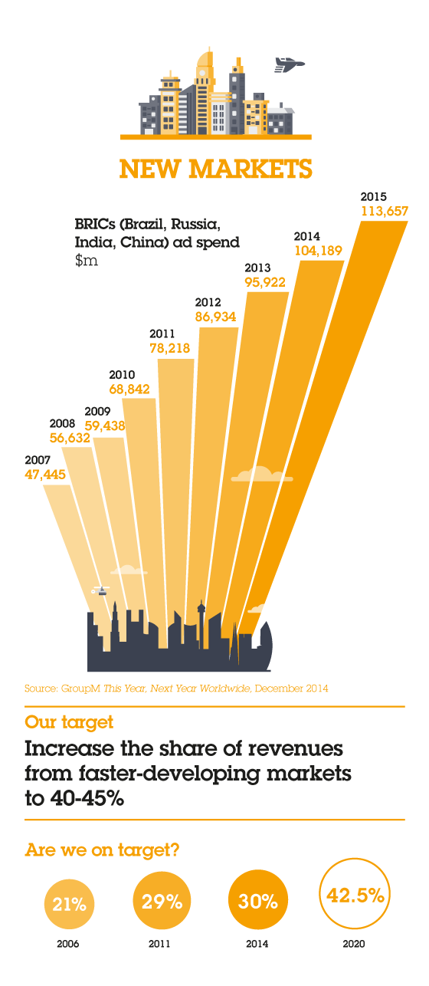

Our current geographical spread

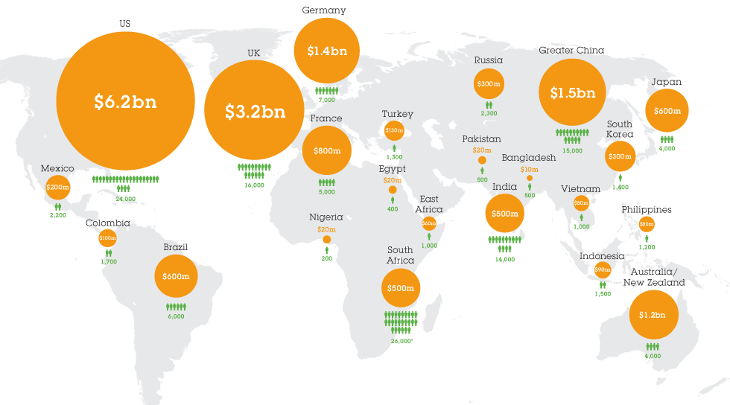

Exercise 1
From the case study description flesh out what you believe might be the drivers that led to the overarching goal and what the specific objectives (with KPIs) might be.

Exercise 2
Identify up to 10 key architecture principles for and complete a principles template for one of those principles.

Exercise 3

From the case study description identify 3 potential stakeholders and complete an entry in a stakeholder matrix for of them.

Exercise 4
From the case study description identify @ 5 business capabilities that might be important for Software Services Inc.

Exercise 5
Describe a potential target Architecture Vision and the proposed transition architectures towards that vision.
(Note: An architecture vision is a clear “sketch” of how the future will be describing key architectural elements presented in any of a number of different formats/media)

Exercise 6
Identify 2 main processes that may be key to the first transition step towards the target architecture and include measures of success and process outcomes.

Exercise 7
Define a first draft of a possible logical information model and identify possible key issues with the current quality of this data.

Exercise 8
Identify potential applications for 1 - 2 of the business capabilities identified in exercise 3 that are key to the first transition step towards the target architecture and propose their technical architecture.

Exercise 9
Propose a technology architecture pattern for the organisation.

Exercise 10
Propose the first 2-3 projects that may be required during the initial transition phase, identify their key deliverables and risk levels.

Note that this course does not teach specific modelling techniques or notations in detail, therefore many of the sample answers use the catalogue / matrix style deliverables from TOGAF. However, if you wish to use a relevant model/diagram in an exercise please do.

